Instalar Rasperry Camera Module y OpenCV en Rasperry Pi

Instalación de Raspberry Camera Module en Raspberry Pi

Actualización del sistema
Escribir en una terminal
$ sudo apt-get update
$ sudo apt-get upgrade
$ sudo apt-get install cmake

Habilitar Raspberry Camera Module
Escribir en una terminal
$ sudo raspi-config
Navegar hasta “Camera” y seleciona “Enable”
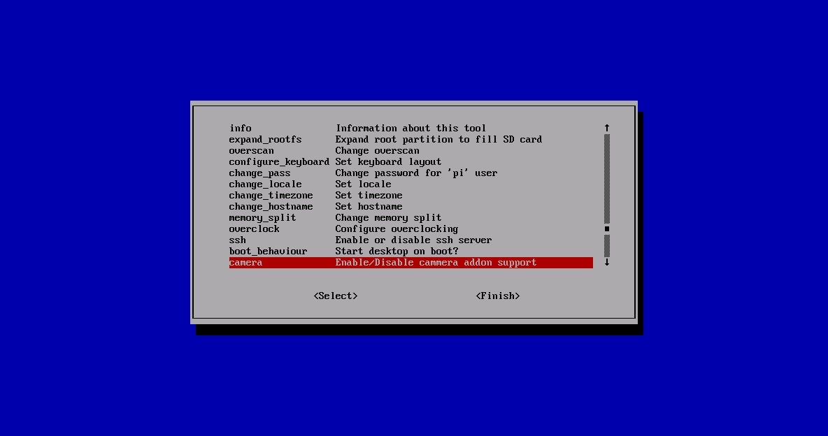
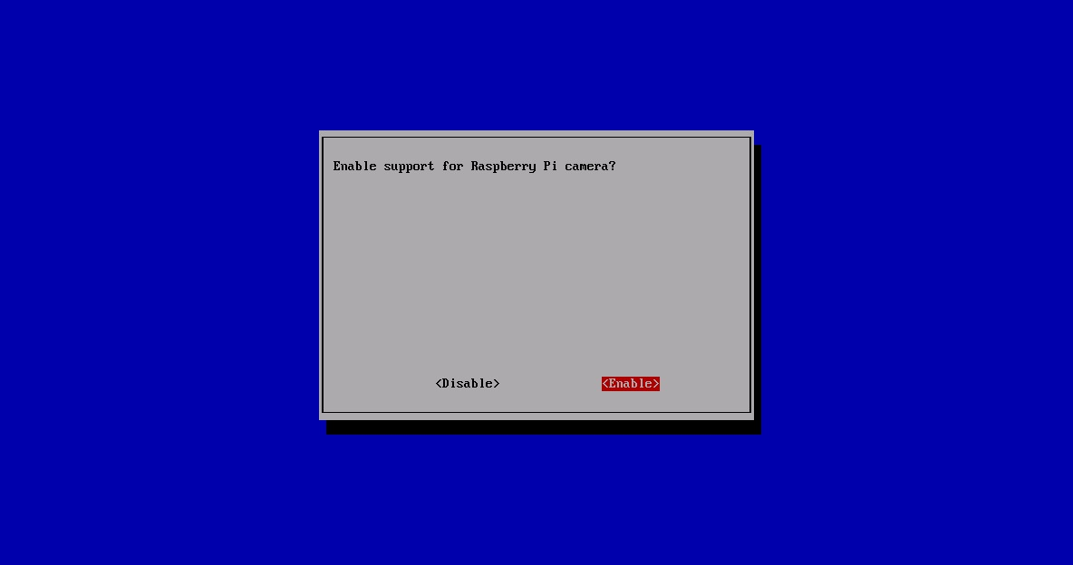
Seleccionar “Finish” para reiniciar
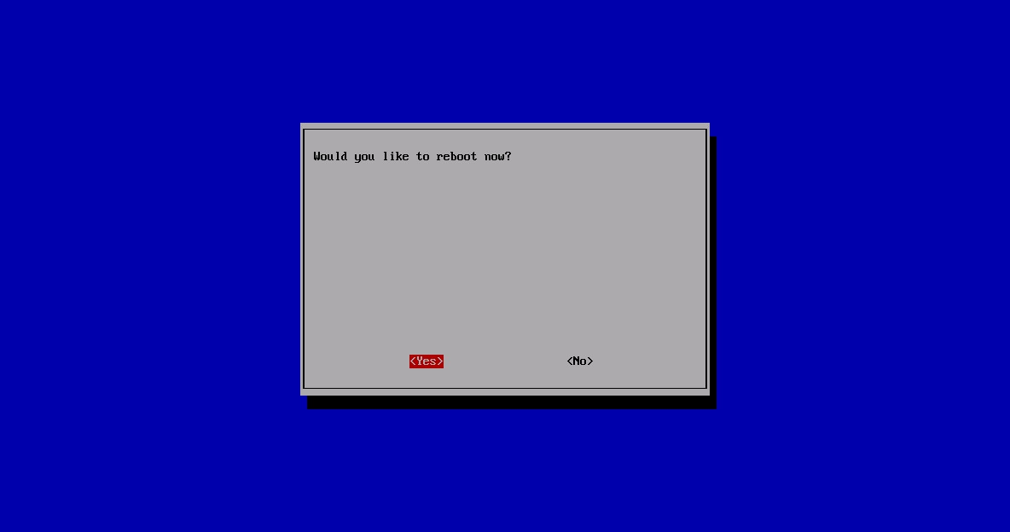

Instalación de OpenCV

Instalación de librerias MMAL y raspivid/raspistill
En primer lugar, tenemos que compilar el paquete completo de librerias MMAL y raspivid/raspistill antes de hacer cualquier otra cosa con OpenCV. Para ello
- Descargar las librerias
$ sudo wget https://github.com/raspberrypi/userland/archive/master.zip
- Descomprimirlas y moverlas al directorio /opt/vc
$ sudo unzip master.zip
$ sudo rm master.zip
$ sudo mv userland-master/ /opt/vc/
- Definir variables
$ cd /opt/vc/userland-master/
$ sed -i 's/if (DEFINED CMAKE_TOOLCHAIN_FILE)/if (NOT DEFINED CMAKE_TOOLCHAIN_FILE)/g' makefiles/cmake/arm-linux.cmake
- Crear un directorio de construcción y compilar (tardará unos minutos)
$ sudo mkdir build
$ cd build
$ sudo cmake -DCMAKE_BUILD_TYPE=Release ..
$ sudo make
$ sudo make install
Se debe haber creado un binario en /opt/vc/bin
Ir a /opt/vc/bin y probar el programa escribiendo: ./raspistill -t 3000
$ cd bin/
$ ./raspistill -t 3000
En esta etapa, se debería ser capaz de modificar este programa para incluir llamadas de la libreria OpenCV que hay que instalar a continuación.

Instalar librería OpenCV

Instalar dependencias
Escribir en una terminal
$ sudo apt-get -y install build-essential
$ sudo apt-get -y install cmake
$ sudo apt-get -y install cmake-curses-gui
$ sudo apt-get -y install pkg-config
$ sudo apt-get -y install libpng12-0
$ sudo apt-get -y install libpng12-dev
$ sudo apt-get -y install libpng++-dev
$ sudo apt-get -y install libpng3
$ sudo apt-get -y install libpnglite-dev
$ sudo apt-get -y install zlib1g-dbg
$ sudo apt-get -y install zlib1g
$ sudo apt-get -y install zlib1g-dev
$ sudo apt-get -y install pngtools
$ sudo apt-get -y install libtiff4-dev
$ sudo apt-get -y install libtiff4
$ sudo apt-get -y install libtiffxx0c2
$ sudo apt-get -y install libtiff-tools
$ sudo apt-get -y install libeigen3-dev
$ sudo apt-get -y install libjpeg8
$ sudo apt-get -y install libjpeg8-dev
$ sudo apt-get -y install libjpeg8-dbg
$ sudo apt-get -y install libjpeg-progs
$ sudo apt-get -y install ffmpeg
$ sudo apt-get -y install libavcodec-dev
$ sudo apt-get -y install libavcodec53
$ sudo apt-get -y install libavformat53
$ sudo apt-get -y install libavformat-dev
$ sudo apt-get -y install libgstreamer0.10-0-dbg
$ sudo apt-get -y install libgstreamer0.10-0
$ sudo apt-get -y install libgstreamer0.10-dev
$ sudo apt-get -y install libxine1-ffmpeg libxine-dev
$ sudo apt-get -y install libxine1-bin
$ sudo apt-get -y install libunicap2
$ sudo apt-get -y install libunicap2-dev
$ sudo apt-get -y install swig
$ sudo apt-get -y install libv4l-0
$ sudo apt-get -y install libv4l-dev
$ sudo apt-get -y install python-numpy
$ sudo apt-get -y install libpython2.6
$ sudo apt-get -y install python-dev
$ sudo apt-get -y install python2.6-dev
$ sudo apt-get -y install libgtk2.0-dev

Instalar OpenCV
Descargar OpenCV (en este caso la última versión es la 2.4.13)
$ wget http://sourceforge.net/projects/opencvlibrary/files/opencv-unix/2.4.13/opencv-2.4.13.zip
Descomprimir el archivo descargado
$ unzip opencv-2.4.8.zip
Preparar para compilar
$ cd opencv-2.4.8
$ mkdir release
$ cd release
$ ccmake ../
Pulsar 'c' para configurar. Una vez hecho alternar las opciones que se desee. Esta es una opcion:
ANT_EXECUTABLE ANT_EXECUTABLE-NOTFOUND
BUILD_DOCS ON
BUILD_EXAMPLES ON
BUILD_JASPER ON
BUILD_JPEG ON
BUILD_OPENEXR ON
BUILD_PACKAGE ON
BUILD_PERF_TESTS ON
BUILD_PNG ON
BUILD_SHARED_LIBS ON
BUILD_TBB OFF
BUILD_TESTS ON
BUILD_TIFF ON
BUILD_WITH_DEBUG_INFO ON
BUILD_ZLIB ON
BUILD_opencv_apps ON
BUILD_opencv_calib3d ON
BUILD_opencv_contrib ON
BUILD_opencv_core ON
BUILD_opencv_features2d ON
BUILD_opencv_flann ON
BUILD_opencv_gpu ON
BUILD_opencv_highgui ON
BUILD_opencv_imgproc ON
BUILD_opencv_legacy ON
BUILD_opencv_ml ON
BUILD_opencv_nonfree ON
BUILD_opencv_objdetect ON
BUILD_opencv_ocl ON
BUILD_opencv_photo ON
BUILD_opencv_python ON
BUILD_opencv_stitching ON
BUILD_opencv_superres ON
BUILD_opencv_ts ON
BUILD_opencv_video ON
BUILD_opencv_videostab ON
BUILD_opencv_world OFF
CLAMDBLAS_INCLUDE_DIR CLAMDBLAS_INCLUDE_DIR-NOTFOUND
CLAMDBLAS_ROOT_DIR CLAMDBLAS_ROOT_DIR-NOTFOUND
CLAMDFFT_INCLUDE_DIR CLAMDFFT_INCLUDE_DIR-NOTFOUND
CLAMDFFT_ROOT_DIR CLAMDFFT_ROOT_DIR-NOTFOUND
CMAKE_BUILD_TYPE Release
CMAKE_CONFIGURATION_TYPES Debug;Release
CMAKE_INSTALL_PREFIX /usr/local
CMAKE_VERBOSE OFF
CUDA_BUILD_CUBIN OFF
CUDA_BUILD_EMULATION OFF
CUDA_HOST_COMPILER /usr/bin/gcc
CUDA_SDK_ROOT_DIR CUDA_SDK_ROOT_DIR-NOTFOUND
CUDA_SEPARABLE_COMPILATION OFF
CUDA_TOOLKIT_ROOT_DIR CUDA_TOOLKIT_ROOT_DIR-NOTFOUND
CUDA_VERBOSE_BUILD OFF
EIGEN_INCLUDE_PATH /usr/include/eigen3
ENABLE_NEON OFF
ENABLE_NOISY_WARNINGS OFF
ENABLE_OMIT_FRAME_POINTER ON
ENABLE_PRECOMPILED_HEADERS ON
ENABLE_PROFILING OFF
ENABLE_SOLUTION_FOLDERS OFF
ENABLE_VFPV3 OFF
EXECUTABLE_OUTPUT_PATH /home/pi/opencv-2.4.8/release/bin
GIGEAPI_INCLUDE_PATH GIGEAPI_INCLUDE_PATH-NOTFOUND
GIGEAPI_LIBRARIES GIGEAPI_LIBRARIES-NOTFOUND
INSTALL_CREATE_DISTRIB OFF
INSTALL_C_EXAMPLES OFF
INSTALL_PYTHON_EXAMPLES OFF
INSTALL_TO_MANGLED_PATHS OFF
OPENCV_CONFIG_FILE_INCLUDE_DIR /home/pi/opencv/opencv-2.4.8/release
OPENCV_EXTRA_MODULES_PATH
OPENCV_WARNINGS_ARE_ERRORS OFF
OPENEXR_INCLUDE_PATH OPENEXR_INCLUDE_PATH-NOTFOUND
PVAPI_INCLUDE_PATH PVAPI_INCLUDE_PATH-NOTFOUND
PYTHON_NUMPY_INCLUDE_DIR /usr/lib/pymodules/python2.7/numpy/core/include
PYTHON_PACKAGES_PATH lib/python2.7/dist-packages
SPHINX_BUILD SPHINX_BUILD-NOTFOUND
WITH_1394 OFF
WITH_CUBLAS OFF
WITH_CUDA OFF
WITH_CUFFT OFF
WITH_EIGEN ON
WITH_FFMPEG ON
WITH_GIGEAPI OFF
WITH_GSTREAMER ON
WITH_GTK ON
WITH_JASPER ON
WITH_JPEG ON
WITH_LIBV4L ON
WITH_NVCUVID OFF
WITH_OPENCL ON
WITH_OPENCLAMDBLAS ON
WITH_OPENCLAMDFFT ON
WITH_OPENEXR ON
WITH_OPENGL ON
WITH_OPENMP OFF
WITH_OPENNI OFF
WITH_PNG ON
WITH_PVAPI ON
WITH_QT OFF
WITH_TBB OFF
WITH_TIFF ON
WITH_UNICAP OFF
WITH_V4L ON
WITH_XIMEA OFF
WITH_XINE OFF
Pulsar 'c' otra vez para configurar los nuevos ajustes. Pulsar 'g' para generar el “Makefile”. Y por último compilar, esto puede tardar unas 10 horas.
$ make
$ sudo make install

Referencias
http://www.raspberrypi.org/camera-board-available-for-sale/
http://thinkrpi.wordpress.com/2013/05/22/opencv-and-camera-board-csi/
http://robertcastle.com/2014/02/installing-opencv-on-a-raspberry-pi/

